

North America > Canada > Ontario > Greater Toronto Area > Toronto

Toronto

For other places with the same name, see Toronto (disambiguation).

Toronto is a diverse, energetic and liveable city, home to many tourist attractions, and seemingly endless dining, shopping and entertainment possibilities. It's the most populous city in Canada, the centre of the country's financial sector, and the provincial capital of Ontario.

Toronto is one of the most culturally and ethnically diverse cities in the world: more than 80 ethnic communities are represented, and over half of the city's residents were born outside Canada.

See also: Toronto/Yonge Street and LGBT Toronto

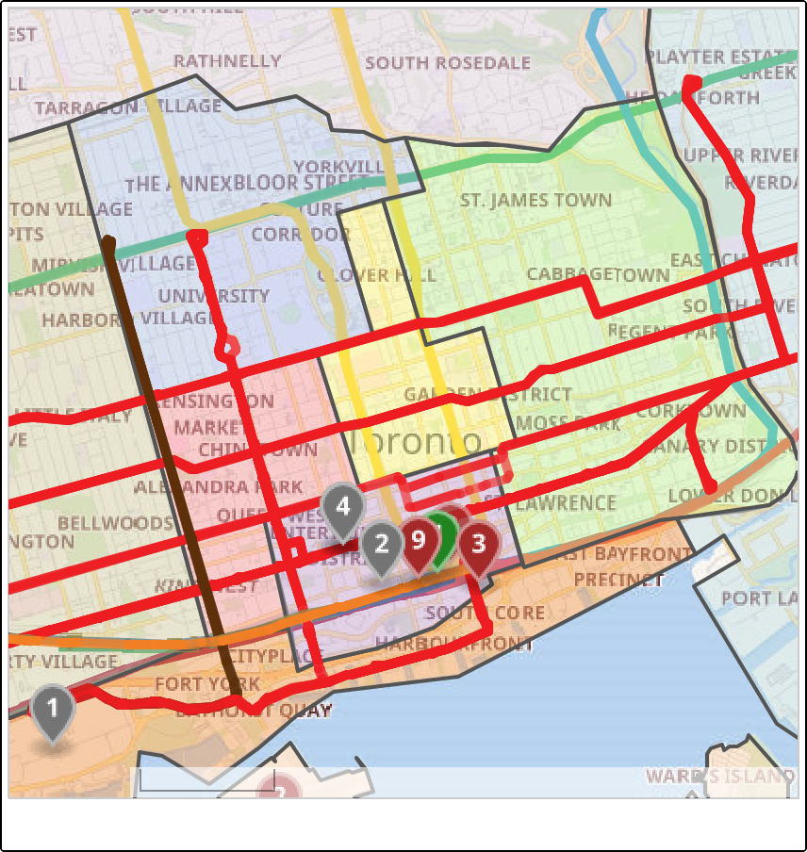Districts

Wikimedia maps | Map data © OpenStreetMap contributors
Map of Toronto
1 km

Toronto is made up of varied and unique neighbourhoods. Covering 631 square kilometres (244 sq mi), Toronto stretches some 32 kilometres (20 mi) along the shores of Lake Ontario. The city is laid out on a very straightforward grid pattern. Streets rarely deviate from the grid, except when topography interferes, such as the curving Don River Valley, and to a lesser degree the Humber and Rouge valleys at opposite ends of the city. Some main thoroughfares intersect the grid at angles. For travel purposes, we have divided Toronto into twelve districts:

Central Toronto
The dense urban core of Toronto. It includes many of the city's attractions and hotels.

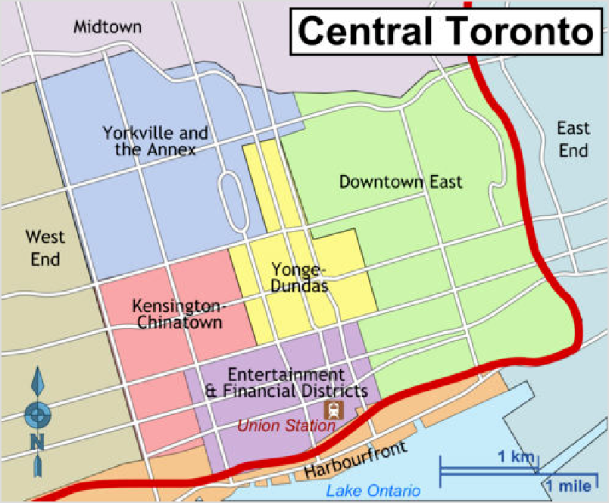Yonge-Dundas

Districts of Downtown Toronto — switch to interactive map
The heart of downtown Toronto with Yonge St, the Eaton Centre, theatres and City Hall.
Entertainment and Financial Districts The entertainment and
financial heart of the city, including some of the city's most prominent tourist attractions: the CN Tower, Rogers Centre, Union Station and the Hockey Hall of Fame.
Kensington-Chinatown Diverse neighbourhoods with lots of little shops, markets and restaurants, and some of the city's best known bars for live music. Includes Queen West and the Fashion District to the south.

Yorkville and the Annex
The boutiques of Yorkville and the museums and student energy of the Annex and University neighbourhoods.

Harbourfront
South of Downtown, this area is popular for its parks and recreational activities. Walk along the water's edge, take a harbour tour by boat, have some family fun at various events at Exhibition Place, or take in a Major League Soccer or Canadian Football League game at BMO Field.

Toronto Islands
Take the ferry to the Toronto Islands. Stroll through the parkland, enjoy the beaches, see the petting zoo, have fun in the amusement park, see the quaint cottages and front- yard gardens of the permanent island community.

Downtown East
Older neighbourhoods between Church St and the Don Valley. Includes Church & Wellesley (Toronto's gay village), Cabbagetown, the St Lawrence Market, Old Town Toronto, and the Distillery District.

Outside Central Toronto

These are the older suburbs that ring the downtown followed by an outer ring of post-war suburbs. There are fewer attractions here, but if you have the time, some of the neighbourhoods are well worth visiting.

Midtown (Yonge & Eglinton, Davisville Village, Forest Hill)
Upscale neighbourhoods with grand old mansions housing the city's moneyed and elite, beautiful parks, and ravines that extend for kilometres. Yonge & Eglinton is becoming a new urban core.

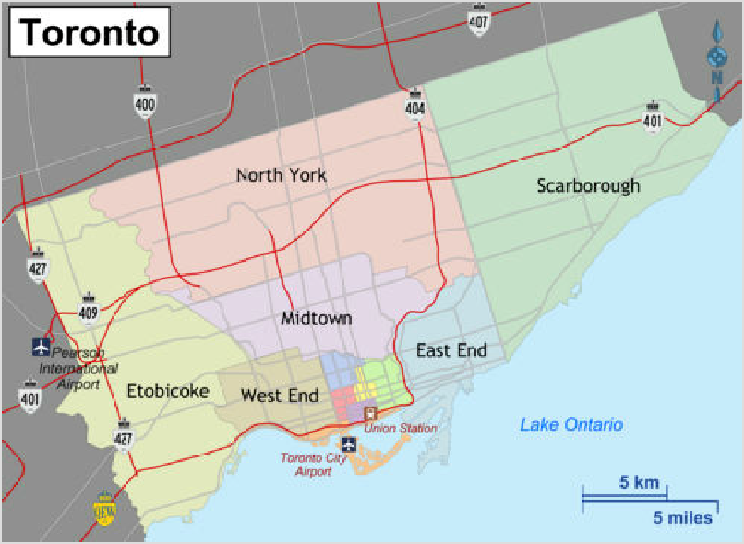West End (Little Italy, Little Portugal, West Queen West, Parkdale, Roncesvalles, High Park) Ethnic enclaves, dive bars, and hipsters abound in this rapidly gentrifying part of town. High Park preserves a slice of green space north from Humber Bay, providing an escape from noisy city life.

Map of Toronto — switch to interactive map
East End (Greektown, Leslieville and The Beaches)
The West End's quainter, quieter alternative, with low-key neighbourhoods and nice beaches. This area hosts ethnic and cultural festivals throughout the summer months. The Beach, centred along Queen Street east of Kingston Road, is alive with weekend foot traffic year- round, out to take in the local businesses, and the lake breezes in the summer.

Etobicoke
An economically diverse suburb with some undiscovered gems along Bloor Street and near the lake in Mimico, New Toronto and Long Branch.

North York
This district is largely suburban but has something to offer the casual tourist. The centre of this district is more densely urban in nature, as it was designed to serve as the downtown of the former City of North York.

Scarborough
The eastern suburb of the city has lots to offer, including the Scarborough Bluffs, Rouge National Urban Park, authentic (and affordable) ethnic cuisine, and the Toronto Zoo.

Outer suburbs and Greater Toronto Area
Although there are fewer attractions, there are ethnic enclaves with ethnic foods and other activities that may be of interest to a traveller in the newer, outer suburbs of Toronto. For example, Markham's population is 48% Chinese and has a lot of interesting shops, businesses, and restaurants. For travel information for the newer suburbs, see the Greater Toronto Area article.

Understand

Toronto has an estimated population of over 3.2 million people as of 2024, and is the heart of the Greater Toronto Area (GTA) which has 7.1 million people. It also anchors the Golden Horseshoe region, which wraps around Lake Ontario from Toronto to Niagara Falls, home to over 11.1 million residents, approximately a quarter of Canada's entire population. Toronto is the fourth largest city and fifth largest urban agglomeration in North America.

Distances between cities in the area can be great as it sprawls along, outward and even wraps around the western end of Lake Ontario; public transit is not always effective enough to make it a quick or seamless trip. Many suburban residents rely on private cars to get around.

Toronto is also known as "the 416" after its first area code (although now 647 and 437 area codes are also used); or since 2014, "the 6", a term coined by the rapper Drake, which represents the area code).

Outlying suburbs are also known as "the 905" after their area code, although this code is also used in the Hamilton and the Niagara Peninsula, stretching from Cobourg and Colborne in the east to the border in Niagara Falls to the southwest.

More than half of its residents were born outside of Canada, and as a result the city is fortunate to host many vibrant bustling neighbourhoods with street signs in several languages.

A popular urban myth has it that the United Nations rated Toronto as "the most multicultural city in the world". While the UN and its agencies are not in the habit of rating cities, it remains a fact that Canada is a nation of immigrants, and Toronto demonstrates this abundantly. A UN agency lists Toronto as second only to Miami as the city with the most foreign-born residents, as about half the city's residents were born outside of Canada. This has been true since the early 20th century, meaning that new waves of immigrants from diverse places have arrived. Toronto's residents represent far more cultural and language groups than Miami, which may be a better measure of multi-culturalism. Most immigrants either pass through Toronto on their way to other parts of the country or stay in Toronto permanently. Many people born abroad consider themselves Canadian as much as native-born Canadians and will be offended if treated otherwise. Within Toronto, most ethnic groups have worked their way into the fabric of Canadian society but retain their distinct ways such as language, dress (if only for special occasions), customs, and food.

Toronto is home to many ethnic festivals throughout the year, several radio stations that broadcast in various languages, and two multilingual television channels. The City of Toronto provides services in 16 different languages while its public transit helpline provides service in 70 languages. Even large department stores such as The Bay in downtown Toronto advertise service in 9 languages. The lingua franca of Toronto, however, remains English.

While older tourist promotional material may claim the Toronto means "meeting place", the city most likely takes its name from the Mohawk word Tkaronto, meaning "where there are trees standing in the water".

History
Spawned out of post-glacial alluvial deposits and bluffs, the area was populated at different times by Iroquois and later Wyandot (Huron) peoples.

European settlement began in the mid-1700s when, drawn by the natural harbour formed by the Toronto Peninsula (now the Toronto Islands), the French built a seldom-occupied fort (Fort Rouillé) near today's Exhibition Place. The city then grew out of a backwoods English trading post established as York in 1793 (it was re-named "Toronto" in 1834). During the War of 1812, Fort York was an important base for the British, and was destroyed during a major battle.

In the 1960s and 1970s, Toronto overtook Montreal as the financial and economic powerhouse of Canada.

In 1998, the cities of Toronto, Scarborough, North York, Etobicoke, and York and the Borough of East York amalgamated to form the current City of Toronto.

Climate
Toronto
Climate chart (explanation)
J F M A M J J A S O N D
24
27
26
19
22
12
15
18
5
15
18
14
8
0
1
10
4
8
3
2
−2 −3
−7 −6
Average max. and min. temperatures in °C
Precipitation+Snow totals in mm
Imperial conversion
[Expand]
Toronto's climate is on the whole on the cool side, and variable conditions can be expected.

Come prepared for winter: winters are cold (temperatures average -3.8°C (25°F) in January), mostly cloudy, at times snowy and uncomfortably windy. However, the type of extreme cold experienced further north in Canada usually lasts for no more than a couple of days at a time. Sometimes during the winter, severe storms can slow down transportation and activities in the city for a day or two. Daylight hours are short and run from 7:45AM to 4:45PM.
65 | 54 | 53 78 76 82 | 77 | 72 | 69 | 69 | 71 | 58
372 | 270 | 198 50 0 0 | 0 | 0 | 0 | 1 | 83 | 241

The city experiences warm and humid summers, but still milder than many US cities. Average daytime highs are around 27 °C (81 °F) and 18 °C (64 °F) for overnight lows in July/August, with many muggy evenings but rarely extreme heat. On
average, the temperature exceeds 30 °C (86 °F) only 12 days per year, but hotter air masses often arrive with moderately high humidity levels. This can raise the humidex to around 38°C or even higher (equivalent to a heat index of 33 °C (91 °F)); and increase overnight lows to 22 °C (72 °F) or above on particularly sweltering days. In the summer, thunderstorms occur from time to time, most lasting less than an hour. Summer days are long, with the sun up as late as 9PM, and sunrises around 5:45AM.

Late spring/early summer and early fall are generally considered to be the best times to visit for weather and less crowds, mid-summer is the peak tourist season, but visitors will find that Toronto's vibrancy extends through the winter with outdoor skating rinks and bundled up club- goers, etc. Toronto's public buildings are nearly all air-conditioned and fully heated.

Areas closer to the downtown core are generally 1 to 1.5°C warmer in winter due to the urban heat island effect. For the rest of the year, areas close to Lake Ontario are warmer by about 1°C due to the moderating effects of the lake. This is especially prominent in March and November when the city receives rain while areas just north of the city receive snow.

Visitor information
1 Ontario Travel Information Centre (http://www.ontariotravel.net), 65 Front Street West (within Union Station; follow signs towards UP Express), ☏ +1 416-314-5899, ontariotravel.toronto@ontario.ca (mailto:ontariotravel.toronto@ontario.ca). M-Sa 9AM-5PM (closed Su). (updated Jan 2024 | )
Destination Toronto (https://www.destinationtoronto.com/). Tourist information from the Toronto Convention and Visitors Association. (updated Jan 2024 | )

Get in

By plane

Toronto Pearson
Main article: Toronto Pearson International Airport

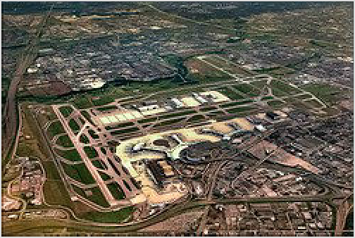1 Toronto Pearson International Airport (http

s://www.torontopearson.com) (YYZ ^{IATA}). (updated May 2022 | ), in Mississauga, is 30-50 minutes by car (depending on traffic) or 25 minutes by train from downtown Toronto and is served by most major international carriers. There are two terminals: Terminal
1 hosts all Air Canada flights and a few other
international (mostly Star Alliance) carriers while Terminal 3 hosts all other airlines. When travelling from Toronto International (and other major Canadian airports) to the United States, travellers will go through United States immigration and customs pre-clearance in Toronto, and should leave some extra time to account for this. The airport has free WiFi internet access.

Pearson International sees the most traffic and connections of all airports in Canada

The main article describes ground transportation to and from Toronto Pearson.

Billy Bishop Airport
- Billy Bishop Toronto City Airport (http://www.portstoronto.com/airport.aspx) (YTZ ^{IATA}), ☏ +1 416-203-6942. This airport serves short-haul flights only and is close to downtown. It is named for a World War I fighter ace, but some locals may call it “Toronto island airport” or simply “Billy Bishop” (updated Jun 2022 | )

Airlines at Billy Bishop Airport
Porter Airlines (https://www.flyporter.com/), toll- free: +1-888-619-8622. This airline uses Billy Bishop as their hub. They are a short-haul carrier that operates Bombardier Dash 8 Q400 turboprop planes to many cities in eastern Canada (Ottawa, Montreal, Quebec City, Halifax, St. John's and others) and parts of the United States (Boston, Chicago, New York/Newark, Washington Dulles and Myrtle Beach). Porter is aggressively fighting for market share and you can take advantage of it by getting low fares, especially if booked 2 weeks or more in advance, combined with complimentary drinks onboard and a waiting lounge with amenities. (updated Apr 2022 | )
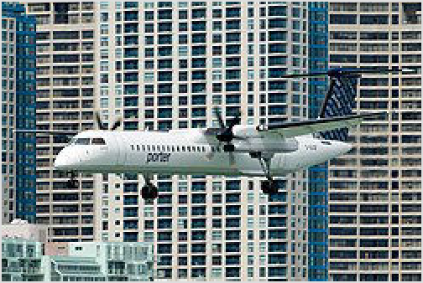Air Canada (https://www.aircanada.com/), ☏ +1-

Porter Airlines offers a network of connections across eastern Canada and northeastern US from their base at Billy Bishop Airport.

514-393-3333, toll-free: +1-888-247-2262. Canada's largest airline. Operates flights to Billy Bishop Airport from Montreal and Ottawa, on Bombardier Q400 turboprop planes. Toronto Pearson International Airport is a hub for this airline with far more flight options including from international destinations. (updated Apr 2022 | )
Propair (https://propair.ca/en/). Service from North Bay and Rouyn-Noranda. (updated Apr 2025 | )

Ground transit from Billy Bishop Airport
One of the main benefits of flying into Billy Bishop is its proximity to the downtown core. Upon landing, you can be downtown within ten minutes. A pedestrian tunnel under the channel takes you to the city. A free ferry service also makes the short crossing: it is just 121 metres, the world's shortest regularly-scheduled ferry route. It operates between TCCA and the mainland every 15 minutes: see full schedule (https://www.billybishopairport.com/to-from/ferry). Once on the mainland, a free shuttle bus (https://www.billybishopairport.com/to-from/shuttle/) connects the terminal with the Fairmont Royal York Hotel, across the street from Union Station.

TTC streetcars are available within a short walk from the mainland ferry terminal:

Route 509 Harbourfront travels east along the waterfront (Queens Quay) to Union Station. Streetcar stops are at the corner of Queens Quay & Bathurst; 4 minute walk.
Route 511 Bathurst provides service north along Bathurst, to Bathurst subway station. Stops are near the corner of Fleet St & Bathurst St; 6 minute walk.
Both of these routes also travel a short distance to the west, terminating at Exhibition Place.
Route 510 Spadina travels north along Spadina Ave to Spadina subway station. It's a bit of a longer walk (900m; about 15 minutes along Queens Quay to Spadina Ave) but can be a good choice if your destination lies along Spadina Ave.
That said, the most convenient connection to TTC subway and GO Transit services remains the free shuttle bus to Union Station.

Other airports
Hamilton International Airport (https://flyhamilton.ca/), (YHM ^{IATA}), about 80 kilometres (50 mi) from downtown Toronto and Niagara Falls, is served by WestJet along with seasonal service by Air Transat and Sunwing to sun destinations. See section on John C. Munro Hamilton International Airport for ground transportation including buses to Toronto.

For frugal travellers coming from the United States, Buffalo-Niagara International Airport (https://www.buffaloairport.com/), (BUF ^{IATA}), is another option. Flights to Buffalo tend to be significantly cheaper than to Pearson, but then you still have to get to Toronto. Megabus (http://www.megabus.com), the airline-type coach service with varying prices and required early booking, runs a daily bus that takes 3 hours, including the border crossing. Several private livery agencies will drive you there for a fee (usually in the $200 range, give or take), or rental cars are available at the airport if you prefer to do the drive yourself.

By bus

Bus terminals
The main bus terminal is in downtown Toronto adjacent to Union railway station:

- Union Station Bus Terminal (GO bus terminal), 81 Bay St (interior pedestrian connection to Union Station rail & subway services). Union Station Bus Terminal (USBT) serves GO Transit, Megabus, Greyhound, Rider Express, and Ontario Northland buses. Like an airport, there are no predetermined bus platform assignments. Check display monitors for the bus departure zone; 10 minutes before departure, monitors will display the bus departure gate. The bus terminal moved to its new location on December 5, 2020; maps might still indicate the older, now closed bus location; the new location is south of the railway corridor.
The Toronto Coach Terminal near Dundas subway station is closed. (updated Dec 2020 | )
Here is a list of minor terminals and stops in various parts of the city. Check the Wikipedia link for a list of bus routes serving each terminal.

- Yorkdale Bus Terminal (across a footbridge from Yorkdale subway station on Line 1). GO Transit buses from Toronto Pearson International Airport, Mississauga, Milton, Brampton and Oshawa; Ontario Northland buses from North Bay, Sudbury, and Timmins; Megabus once daily from Kingston. (updated Mar 2019 | )
- York Mills Bus Terminal (at York Mills subway station on Line 1). GO Transit buses from Mississauga, Milton, Brampton and Oshawa. (updated Mar 2019 | )
- Finch Bus Terminal (adjacent to Finch subway station on Line 1). GO Transit buses from Toronto Pearson International Airport, Mississauga, Milton, Brampton, Keswick and Oshawa. (updated Mar 2019 | )
- Scarborough Centre Bus Terminal (near Scarborough Centre Station on subway Line 3 Scarborough). Because of the closure of the Scarborough Centre Bus Terminal until about 2030, stops for intercity buses are scattered around the Scarborough Centre district. See Toronto/Scarborough#By bus for details by carrier. GO Transit, Megabus, and FlixBus stop at Scarborough Centre. (updated Aug 2023 | )
See also Toronto Pearson International Airport, Ground Transportation, for more intercity bus routes.

Bus operators
FlixBus (https://www.flixbus.ca/). Bus service to Toronto from Ottawa (4.75 hours), Peterborough, Kingston, Whitby, Kitchener (2-2.25 hours), Stratford, Cambridge, St. Catharines (1.5 hours), Niagara Falls (1.75 hours), Welland, Port Colborne, Hamilton, Brantford, Chatham-Kent, London (3 hours), Sarnia, Windsor (6 hours), Sudbury, North Bay, Parry Sound, Barrie, Owen Sound, Detroit (6.25-6.5 hours), and Buffalo (2.75-4 hours).
Seasonal service from Port Elgin and Southampton. (updated Apr 2022 | )

GO Transit (https://www.gotransit.com/), ☏ +1-416-869-3200, toll-free: +1-888-438-6646. GO Transit runs bus and rail commuter/regional transit within and near the Greater Toronto Area. GO Transit buses make connections to many nearby cities including: Oshawa, Peterborough, Hamilton, Niagara Falls, Barrie, Guelph, and Kitchener. (updated May 2022 | )
Intercity Bus (https://www.intercitybus.ca/routes/). Service from London, Sarnia, Strathroy, Woodstock, and Kitchener. (updated Mar 2024 | )
Megabus (https://ca.megabus.com/) (Coach Canada), toll-free: +1-866-488-4452. Operates buses to Toronto from Montreal (5.75-7 hr) or Ottawa (5.25 hr) via Kingston (3 hr); from Grimsby, St. Catharines, and Niagara Falls (2 hr). Megabus offers Wi-Fi and electrical outlets on many of its buses. A service from London is offered by Megabus through Badder Bus. Service from the United States (Buffalo, New York City, Philadelphia, Washington D. C.) is also available. (updated Apr 2022 | )
Ontario Northland (https://www.ontarionorthland.ca/), toll-free: +1-800-461-8558. Operates bus routes primarily in Northern Ontario. Routes travel as far west as Winnipeg, Manitoba and as far east as Ottawa. (updated Apr 2022 | ) The following routes travel to Toronto:
To Toronto from North Bay including stops in Huntsville, Bracebridge, Gravenhurst, Washago (some trips), Orillia (stop trips), and Barrie. Travel time to Toronto from North Bay is 5.75-6 hours, from Huntsville is 3.25-4 hours, from Barrie is 1.25 hours.
Connections available at North Bay from Cochrane, Kirkland Lake, Ottawa, and Timmins.
To Toronto from Sudbury including stops in Parry Sound, Orillia (some trips), and Barrie. Travel time to Toronto from Sudbury is 5.5-6.5 hours, from Parry Sound is 3.5-3.75 hours, and from Barrie is 1-1.5 hours. Connections available at North Bay from Ottawa, Sault Sainte Marie, and Timmins.
Travel to Toronto from Winnipeg involves timed transfers between bus routes at Thunder Bay, Sault Ste. Marie, and Sudbury. To reach Toronto from Winnipeg is 1 day 9 hours.
Onex Bus (https://www.onexbus.com/home), ☏ +1-647-477-5500, info@onexbus.ca (mail to:info@onexbus.ca). Bus service to Toronto from Kitchener and London. (updated Jul 2021 | )
Orléans Express (https://www.orleansexpress.com/en/). Service from Ottawa and Montreal. (updated May 2025 | )
Rider Express (https://riderexpress.ca), toll-free: +1-833-583-3636. Offers service to Toronto from Ottawa via Kingston and Belleville. Travel time to Toronto from Ottawa is 5.25 hours and from Kingston is 3 hours. Also service from Ottawa via Peterborough. (updated Mar 2025 | )
Maple Bus (https://maplebus.ca/). Shuttle service from Ottawa, Kingston, Napanee, Brockville, Belleville, Trenton, Cobourg, Port Hope, and Oshawa.

By train
See also: Rail travel in Canada and GO Transit
- Union Station (https://www.toronto.ca/services-payments/venues-facilities-boo
kings/booking-city-facilities/union-station/) (YBZ ^{IATA}), 65 Front Street West (between Bay St and York St). 5:30AM-12:45AM or until last train. Opened in 1927, Toronto's Union Station is one of the grandest, most impressive train stations in North America, with the ceiling of its enormous Great Hall rising to a height equivalent to seven stories. The Grand Hall accommodates the VIA Rail ticket counters and gives access to VIA train platforms via the branching VIA Concourse. The 9 Union Pearson Express station is 250 metres west of the Great Hall via an enclosed pedestrian corridor. The GO York Concourse on the lower level at the west (York Street) end of the station has GO Transit ticket counters and access to GO train platforms. (A food court is below the GO York Concourse.) Union Station Bus Terminal is on the

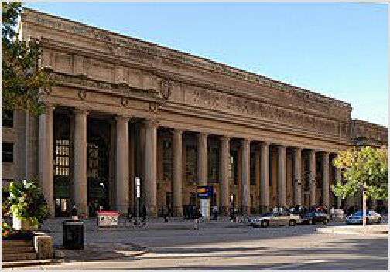east side of Bay Street, south of the railway tracks. The TTC Union subway station is at the north-east corner of the main building, and serves subway Line 1, and the 509 and 510 streetcars through the Harbourfront district.
Union Station

The following are the railway services operating out of Union Station:

Amtrak (https://www.amtrak.com/home), ☏ +1- 215-856-7924, toll-free: +1-800-872-7245. Operates trains throughout the United States of
America. (updated Jul 2022 | ) Amtrak operates the
Maple Leaf train service daily between Toronto and New York City, in partnership with VIA Rail Canada (https://www.viarail.ca/). Stops between Toronto and New York City include in Oakville, Burlington, Grimsby, St. Catharines, Niagara Falls (Ontario), Niagara Falls (New York), Buffalo, Buffalo (Depew), Rochester, Syracuse, Rome, Utica, Schenectady, Albany (Rensselaer), Hudson, Rhinecliff, Poughkeepsie, Croton-on-Hudson, and Yonkers. Travel time to Toronto from Niagara Falls (Ontario) is 2 hours, from Buffalo is 4.25 hours, from Syracuse is 6.75 hours, from Albany is 9.5 hours, and from New York City is 12.5 hours.
Border crossing processing takes place in Niagara Falls, where passengers must detrain with their baggage. Train crew members are staffed by VIA Rail within Canada, and by Amtrak within the United States.
GO Transit (https://www.gotransit.com/), ☏ +1-416-869-3200, toll-free: +1-888-438-6646. GO Transit operates 7 commuter rail lines radiating from Toronto serving smaller cities within and near the Greater Toronto Area. The lines have various service levels varying from all-day service to limited mid-day service to only rush-hour, peak-direction service. Most fares can be paid by credit, debit or Presto card. The following are some of the destinations. (updated May 2022 | )
The Barrie line serves Vaughan, Aurora, Newmarket, East Gwillimbury and Barrie daily. The Kitchener line serves Brampton, Georgetown, Acton, Guelph and Kitchener daily.
The Lakeshore West line operates daily serving Mississauga, Oakville, Burlington, Hamilton, St. Catharines and Niagara Falls.
The Lakeshore East line operates daily serving Pickering, Ajax, and Whitby and Oshawa. The Stouffville line operates daily serving Markham.
Other GO rail destinations have only rush-hour, peak-direction service.
Union Pearson Express (https://www.upexpress.com/) (UP Express), ☏ +1 416-869- 3300, toll-free: +1-844-438-6687. Operates trains between Union Station and Toronto Pearson International Airport. Trip time is 25 minutes. Trains operate every 15 minutes daily from early morning until the late evening. As of April 2022, one-way fare for adults is $12.35, but it is $9.25 if paid by credit, debit or Presto card. (updated May 2022 | )
VIA Rail Canada (https://www.viarail.ca/), toll-free: +1-888-842-7245. Operates many intercity trains across Canada. (updated Apr 2022 | ) See Rail travel in Canada for more details. Train routes operating to Toronto:
Between Montreal and Toronto including stops in Dorval, Cornwall, Brockville, Kingston, Belleville, Cobourg, and Oshawa. Travel time to Toronto from Montreal is 5.25-5.5 hours and from Kingston is 2.5-2.75 hours.
Between Ottawa and Toronto including stops in Smiths Falls, Brockville, Gananoque, Kingston, Napanee, Belleville, Trenton, Cobourg, Port Hope, and Oshawa. Travel time to Toronto from Ottawa is 4.25-4.75 hours and from Kingston is 2.5-2.75 hours.
Between Sarnia and Toronto including stops in London, St. Marys, Stratford, Kitchener, Guelph, Georgetown, Brampton, and Mississauga. Travel time to Toronto from Sarnia is 5 hours, from London is 3.75 hours, and from Kitchener is 1.5 hours.

Between Vancouver and Toronto on The Canadian, which operates several trips per week. Travel time to Toronto from Vancouver is 3 days 20.5 hours, from Kamloops is 3 days 10.25 hours, from Jasper is 3 days, from Edmonton is 2 days 16.75 hours, from Saskatoon is 2 days 5.5 hours, from Winnipeg is 1 day 14 hours, and from Sudbury is
9.75 hours. Stops between Sudbury and Toronto include Parry Sound (5.75 hours from Toronto) and Washago.
Between Windsor and Toronto including stops in Chatham, London, Ingersoll, Woodstock, Brantford, Burlington, and Oakville. Travel time to Toronto from Windsor is 4.25-4.5 hours, from London is 3.25-3.5 hours, and from Brantford is 1.25 hours. There are no direct trains from Chicago, but you can catch Amtrak's Wolverine service from Chicago to Detroit, then transfer onto one of VIA Rail's trains after crossing the border into Windsor by public transport.

By car
Major highways leading into Toronto are the Queen Elizabeth Way (QEW), the 404, the 401, the 400, and the 427. Toronto is the largest city in Canada, so signs pointing you to Toronto are common. Traffic on incoming highways can be extremely heavy especially during rush hours. In the downtown core there are many turn restrictions, particularly from main thoroughfares to other main thoroughfares (e.g. Yonge to Dundas Streets).

The main streets in Toronto are laid out in a grid pattern that makes it one of the easiest cities to get around in by car. Getting from point to point anywhere in the city can be achieved with only a few turns. Parking in the downtown core can be expensive and hard to find, but tends to be plentiful and inexpensive or free in the outer districts of Etobicoke, North York and Scarborough. Although there is an extensive grid of local bus routes, travel by automobile may be faster and more convenient in the outer districts.
Free parking do exist in the downtown core for those who don't mind an extra 5-10 min walk. SpotAngels is an actively maintained app that has maps of where they are.

Transit bylaws
Toronto follows some bylaws related to the transit system (especially streetcars) that often confuse or surprise visiting drivers:

Yield to public transit buses signalling to merge left into traffic from a bus stop.
Stay out of reserved public transit lanes during the rush hours, except to make a right-hand turn at the next cross street. A few transit lanes have restrictions from 7AM-7PM. While the restrictions are in effect, only transit vehicles, taxis and bicycles may use these lanes. Newer bus only lanes are painted red and may only be used by TTC vehicles or bicycles 24 hours a day, 7 days a week (except when making a right turn).
Avoid King Street between Jarvis and Bathurst streets as no through automobile traffic (http s://www.toronto.ca/services-payments/streets-parking-transportation/transportation-projects/k ing-street-pilot/how-to-use-the-king-street-transit-pilot/) is allowed; such traffic must turn right after travelling a few blocks as per signage. Through traffic in this zone is allowed only for streetcars (trams) and bicycles.
Never pass a streetcar running in your direction that is stopped in the middle of the street with its doors open. Passing is illegal and dangerous for passengers boarding or leaving the streetcar. Also, you should yield to people entering the street to board an approaching streetcar. Continue only after the streetcar doors close. Exception: You may pass a streetcar where there is a boarding platform between the streetcar and traffic lane, but watch out for pedestrians walking between the platform and the sidewalk.

Give wide berth to streetcars turning at a street intersection; streetcars have a wide overhang on curves, which is indicated on the road by dashed white lines. If your car is stopped too close to a streetcar curve, you may be forced to back up or squeeze more to the right.
Give wide berth to emergency vehicles with sirens or flashing red lights, and pull over to the side of the road safely but quickly.

Get around

Toronto is huge, and most roads run for very long distances. Streetcar rail, subway rail, and intercity rail services are clean and efficient, and it's entirely possible to get around Toronto without a car, especially downtown. You may find it quicker and easier to drive, but the highways regularly backup during rush hour (7AM-10AM and 4PM-7PM). Toronto has plentiful parking garages downtown, but they are very expensive.

Many in Toronto travel by bicycle (especially in the warmer months) and this mode is very convenient for getting around the downtown district. Not all motorists will give way to cyclists, and not all cyclists comply with the rules of the road; caution is recommended.

By car
Getting around by car is the easiest method to get around outside of the downtown area. Roads are wide, have many lanes, and parking is free and plentiful. Arterial roads are generally laid out 2 kilometres (1.2 mi) apart, although they are closer in the west and east ends of the city.

There are many freeways within Toronto.

Highway 401 (locally, the four-oh-one) crosses the north side of the city and is very busy. Highway 401 has a collector-express system. The express lanes of the highway have fewer exits, while the collector lanes generally have all the exits. After every 3 or 4 exits, there is an interchange between the collectors and express lanes, so motorists who need to exit can get into the collectors, and those travelling a longer distance can go into the express lanes.
When there's a lot of traffic, it is possible for the collectors to be jammed, but not the express, and vice versa. It is best to listen to traffic reports in order to avoid traffic in this case. AM 680 on your radio has traffic and weather reports every 10 minutes (on the 1's).
Highway 427 crosses the west side of the city. It begins at the QEW/Gardiner Expressway interchange and ends in Vaughan. It also has a short express-collector system near the airport; be sure to follow the signs in order to get where you need to go.
Highway 400 has a short stub in Toronto and ends at Highway 401. Highway 400 goes north into the suburbs and later to Barrie.
Allen Road is a short freeway that was supposed to be part of a longer Spadina Expressway. The rest of the expressway was cancelled and Allen Road was the short stub that remained. Allen Road begins at Eglinton Avenue, and ends north of Highway 401 and becomes Dufferin Street. Traffic going south is usually backed up because the freeway ends abruptly at a signalized T-intersection at Eglinton.
Highway 404 also has a short stub in Toronto, and goes north to the suburbs, such as Aurora and Newmarket. Highway 404, after interchanging with Highway 401 when going south, becomes the Don Valley Parkway.
Don Valley Parkway (DVP) is a freeway that connects northern Toronto to downtown Toronto. Exits on the DVP require motorists to slow down more than you would on other Ontario expressways, due to the nature of the terrain. The DVP begins at the Gardiner Expressway in downtown and ends at Highway 401 in the north, then contines as Highway 404.

Gardiner Expressway is a freeway serving downtown Toronto. It begins at QEW/Highway 427 interchange and crossing downtown Toronto, ending at Don Valley Parkway. Half of the route is elevated, making for great views of the city.
Highway 409 is a short freeway designed to connect directly with Toronto Pearson International Airport. It begins at Highway 401, interchanges with Highway 427, and ends at the airport.
Getting around in downtown Toronto by car is a lot harder, however, and perhaps taking transit might be better. Parking is scarce and could be expensive, depending on where you park and whether you park on the street or on private lots. Driving on downtown streets also takes a lot more patience as speeds are slower, and hazards are more numerous.

Ideally, avoid driving in downtown areas as parking fees are high. Ride-sharing services are widely available and a stress-free alternative.

By public transit
Toronto Transit Commission (https://www.ttc.ca/) (TTC), ☏ +1 416-393-4636. Toronto's main transit system. TTC consists of buses, streetcars (trams) and subway lines. (updated May 2022 | )

Fares
The following are the fares effective August 15, 2023:

Cash fare: adult (20-64) $3.35, senior (65+) $2.30, youth (13-19) $2.40 Contactless credit or debit card: adult fare only, $3.30
Presto card: adult $3.30, senior $2.25, youth $2.35
Presto ticket: adult fare only, one-ride $3.35, two-ride $6.70, day pass $13.50 Children (12 or younger): free.
Child, youth and senior riders must be prepared to show proof of age for reduced fares on request.

Paying by Presto
Presto is an electronic fare payment system used on the TTC where riders pay fares by tapping a contactless credit or debit card, Presto card or Presto ticket on a Presto fare reader. The Presto fare system is used by most public transit services in the Greater Toronto Area, including the TTC, GO Transit and UP Express.

Presto card is a multiple-use, electronic fare card with a stored balance. Unless you are eligible for reduced senior/youth fares, it is simpler to use a credit or debit card instead of a Presto card. Physical Presto cards can be obtained for $4 from the Presto vending machines at TTC, GO and UP stations (cash, credit cards and debit cards are accepted at the large black machines) at most Shoppers Drug Mart and select Loblaws stores across the city, while digital Presto cards via Apple Wallet and Google Wallet can be installed onto a compatible smartphone or smartwatch for free. All physical and digital Presto cards are automatically configured to deduct the regular adult fare by default. For reduced senior/youth fares, the customer must have the card's fare type changed by seeing a physical agent at an authorized in-person Presto customer service outlet

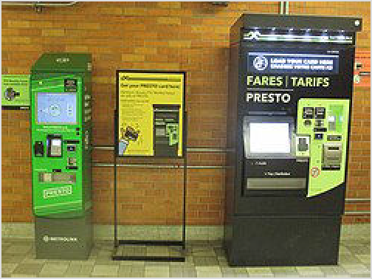(not a vending machine); proof of age may be required. Presto card holders are entitled to discounts or offers (htt ps://www.prestocard.ca/en/about/presto-perks) for certain attractions in the Greater Toronto Area.

Presto tickets are single-use, paper-disposable electronic tickets with no stored balance which must be used within 90 days of purchase (unused tickets can be exchanged for up to one year past expiration by mailing them in to TTC). If you are paying a single-ride fare with a credit or debit card, you do not need Presto tickets. They can only be used for TTC services, (they are accepted at all TTC stations regardless of whether they are located in Toronto or York Region, and on surface

The Presto machine on the right sells Presto cards & tickets. Both can upload funds to a physical Presto card.

routes/vehicles within the City of Toronto limits and for TTC buses going to and from Pearson Airport). They are sold from Presto vending machines at all TTC stations at most Shoppers Drug Mart and select Loblaws locations across Toronto and come in three varieties: one-ride, two-ride and day pass. The TTC Presto day pass allows one person unlimited travel on the day of use from first tap until 3AM the next morning.
Using Presto, you must tap your credit card, debit card, Presto card or Presto ticket on the Presto fare reader located on top of TTC station faregates, on the streetcar or bus doors, or the on-street platforms for Lines 5 and 6. To avoid accidental double charging, keep any unused credit and debit cards away from the Presto reader, and always tap the same card or ticket during your trip. If travelling as a group, each rider must use a separate card or ticket.

Customers paying a single-ride TTC fare with a credit, debit or Presto card, or a 1-ride Presto ticket are entitled to two hours of unlimited travel on all TTC services, allowing unlimited stopovers or a round trip.

For riders paying by credit, debit or Presto card, free or discounted transfers are available between the TTC and the following transit operators: GO Transit, Hamilton Street Railway, Burlington Transit, Oakville Transit, MiWay (Mississauga), Brampton Transit, York Region Transit and Durham Region Transit. For such trips, riders pay only one fare instead of paying multiple fares when transferring from one transit operator to another. If transferring to or from GO Transit, only the GO fare is charged by the end of the trip. Such trips must be completed within two hours, or three hours if using GO Transit. This free or discounted transfer is not available to riders paying by cash, Presto ticket or using UP Express trains operating between Union Station and Pearson Airport.

Paying by cash
If you pay by cash, exact cash (no change provided) is required. You must request for paper transfer (also called a POP ticket) to serve as proof of payment and to transfer to another TTC vehicle at designated transfer locations. Paper transfers are valid for a one-way continuous trip and stopovers and return trips are not permitted (unlike paying by credit, debit or Presto card). Unstaffed automated subway entrances do not accept exact cash fares or paper transfers. If you are paying the adult cash fare, Presto tickets are a better alternative than paying exact cash.

The procedures for cash payment vary by vehicle mode:

At subway stations, there is at least one staffed entrance where you can deposit exact cash into a fare box. After passing the fare gates, obtain a transfer from a red machine labelled "transfer/POP".
On buses, pay exact cash fare at the front door of the vehicle, and ask the driver for a paper transfer.
On streetcars, there are cash payment machines near the second and third doors of the vehicle. After you insert exact cash fare into the vending machine, it will give you a paper POP/transfer.
For Lines 5 and 6, underground stations have at least one staffed entrance where you deposit exact cash into the fare box, after passing through the fare gates obtain a paper transfer from the red transfers machine. At on-street stops, there is a cash payment machine on the platform where you deposit exact cash into the vending machine and obtain a paper POP/transfer.

Subway and light rail
Trains operate M-Sa roughly 6AM-1:30AM, and Su 8AM-1:30AM.

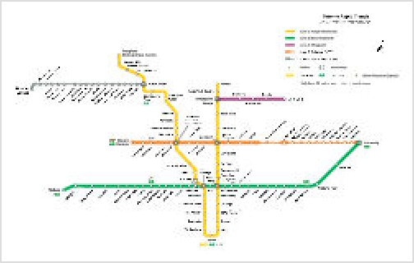As of Feb 2026, the subway and light rail system has five lines:

Toronto subway system

Line Yonge-University runs in a 'U' shape,
1
travelling from North York south along Yonge Street, through the downtown area to Union Station, then travelling north through North York to Vaughan.
Line Bloor-Danforth runs east-west along Bloor
2
Street and Danforth Avenue.
Line Sheppard runs east from Line 1 along
4
Sheppard Avenue to Fairview Mall at Don Mills Station.
Line Eglinton runs east along Eglinton Avenue between Mount Dennis and Kennedy
5
Stations.
Line Finch West runs west from Line 1 at Finch West Station along Finch Avenue West to
6
Humber College.
Much of Lines 5 and 6 run on the surface in the middle of a street. Before boarding a Line 5 or 6 train on the street, remember to pay/validate your fare before boarding the train. A number of underground stations on Line 5 are several levels deep with elevators and escalators only at the main entrance; to avoid an exhausting climb, do not use the secondary entrances.

Line Scarborough is no longer in service. Until the extension of the Line 2 underground
3
subway opens (estimated 2030), the service has been replaced by interim bus services including the 903 Kennedy-Scarborough Express running between Kennedy and Scarborough Centre stations, and 8 other TTC bus routes. These routes have been extended from Scarborough Centre to operate as express services to Kennedy station. (All TTC bus routes that depart from Platform B at Kennedy station service Scarborough Centre station before continuing along their respective routes.)
Sections of the subway and light rail system often close on weekends or late evening for maintenance, with buses replacing each closed section. The TTC gives notice (https://www.ttc.c a/service-alerts) of such closures a few days in advance. Expect a longer travel time during such closures; staff will be on hand to direct passengers.

Streetcars

TTC Subway, Light Rail and Streetcar Map (https://cdn.ttc.ca/-/media/Project/TTC/DevPr oto/Images/Home/Routes-and-Schedules/Landing-page-pdfs/TTC_SubwayStreetcarLightr ailMap.pdf), omitting most streetcar diversions

Toronto is one of the few cities in North America (and the only city in Canada) to have kept any of its streetcar routes. Most streetcar lines serve the south, central part of the city. Note the following:

The TTC often diverts streetcars around construction projects potentially resulting in a substantially changed route for several months. Maps posted on the TTC website, in stations and in waiting shelters generally do not reflect such diversions. Ideally, riders should check the TTC webpage: Streetcar Services Changes (https://www.ttc.ca/service-advisories/Streetc ar-Service-Changes) for diversions to avoid ending up in the wrong place.
Buses replacing all or part of a streetcar route will bear the streetcar route number and route name.
When getting on and off streetcars, make sure that the traffic is stopped in the lane next to the streetcar. Also, be aware of pickpockets in crowded rush hour situations.

Other services
From roughly 1:30AM to 6AM (8AM on Sundays), the subway system and all day-time streetcar and bus routes are replaced by the Blue Night Network (https://cdn.ttc.ca/-/media/Project/T TC/DevProto/Images/Home/Routes-and-Schedules/Landing-page-pdfs/TTC_BlueNightNetwor kMap_2024-03.pdf). Night bus and streetcar routes are all numbered in the 300-series, and use the same fares as day-time routes. Night route 320 Yonge replaces the subway line 1 and offers frequent service. Most other night routes have 30-minute frequency.

Express bus routes (https://cdn.ttc.ca/-/media/Project/TTC/DevProto/Images/Home/Route s-and-Schedules/Landing-page-pdfs/TTC_ExpressNetworkMap_2021-11.pdf) (numbered in the 900 series) often follow local bus routes but with fewer stops, stopping mainly at transfer points. The 900 Airport Express (https://www.ttc.ca/riding-the-ttc/Service-to-the-airport/Toronto-Pea rson-International-Airport) goes to Toronto Pearson Airport. Some express routes operate all day, every day; others may run only during rush hours. Fares are the same as on other TTC routes.

By taxi
Taxis are plentiful and safe, but not cheap. The base rate is $4.25, with an average 5 km (3.1 mi) trip costing $13. As with most big cities, driving a car downtown can be annoying; parking is often hard to find and expensive, and traffic along certain streets can make vehicle travel slower than mass transit. However, traveling longer distances, when not close to subway lines is often significantly faster by car or taxi.

By ride hailing
Lyft (https://www.lyft.com/rider/cities/city-of-toronto-on). (updated Jul 2022 | )
Uber (https://www.uber.com/cities/toronto). UberX service is available via smartphone app throughout the city with fares running roughly half the price of a taxi. An average 5 km (3.1 mi) trip costs roughly $8.25. (updated Jul 2022 | )

By bicycle
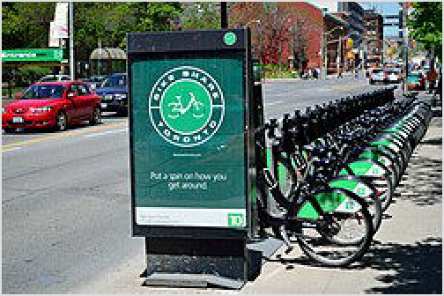Toronto is trying very hard to become a bike-friendly city, with dedicated bike lanes being added all the time. There are many casual cyclists out all the time. And it is fast: door to door, in all of downtown Toronto, a bike beats a car or transit nearly every time.

Bike Share Toronto rack near the

There can be hostility between automobiles and cyclists. Generally speaking, if you are on the road, you are expected to obey the same laws as cars, and you are not allowed to ride on the sidewalk.

The city is predominantly flat, aside from a general climb

Toronto City Hall.

away from Lake Ontario and the deeply indented, forested Don Valley and Humber River Valley. Post-and-ring locking posts are present throughout the city. There are many bike-only lanes on major roads and threading through various neighbourhoods and parks. The city publishes a cycling map, available on the city website (http://www.toronto.ca/cycling/map/index.htm).

Bike Share Toronto (http://www.bikesharetoronto.com/) provides a public bike system with over 10,000 bikes available at 1,000 stations throughout the city. Subscriptions start at $15 for 24 hours and allow you to use a bike for 90 minutes or less, as much as you like (usage fees apply for trips longer than 90 minutes). It operates 24 hours a day, all year long (but see the warning below about winter biking). Several businesses also offer bicycle rentals (http://www.yellowpage s.ca/search/si/1/Bicycle+Rental/Toronto+ON).
It is a provincial law that cyclists under 18 must wear a helmet, and all riders must have a bike with reflectors and a bell. This tends to only be enforced when the police go on their annual "cycling blitz".

Some dangers:

Beware of parked cars - often accidents are not caused by moving cars, but rather by careless drivers or passengers who unexpectedly open their driver's side door.
Be cautious of streetcar tracks as bike wheels can be easily caught and cause a spill.
Although you will certainly see many locals riding the streets year-round, biking in the winter months is enjoyable only with proper equipment and reasonable skills; winter weather is cold, it can be quite windy, and snow removal is often imperfect.
Some recommended cycling routes:

By far one of the most popular bike paths is the Martin Goodman Trail, the east-west route that hugs Lake Ontario, spanning the city from Etobicoke to the eastern ends of the city. This path is also often used by pedestrians and rollerbladers.
The Don River trail system begins at the lake (near Queen and Broadview) and travels very far north and east. During or after heavy rains, avoid lower sections of the trails.
A special treat for bikers of all levels is a tour through Tommy Thompson Park (Leslie St Spit) to the lighthouse and bird sanctuaries (no cars!), which is open on weekends only. Start at Queen and Leslie and head south.
A visit to Toronto Islands from the ferry docks at the southern end of Bay Street is a great way to spend a bike-friendly, relaxed afternoon by bike. There are no private cars on the Toronto Islands.

By ferry
The trip to the Toronto Islands from the downtown core (Bay St and Queens Quay) is a pleasant 15-minute ferry ride, with frequent summer service and the best views of the Toronto skyline.

There are also guided sailing vessels that take tours of the inner and outer harbours, and circumnavigate Toronto Islands. Ticket booths are found behind Harbourfront Centre in the Harbourfront district.

See

Individual listings can be found in Toronto's district articles

Museums
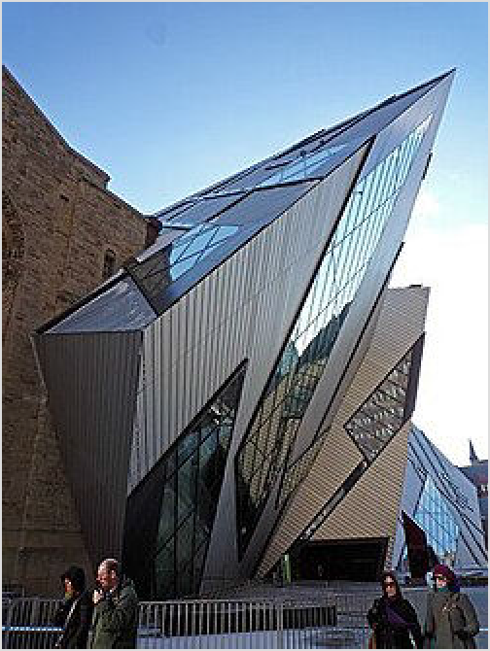Art Gallery of Ontario. The largest art gallery in Canada. It has a great Canadian paintings exhibit and the world's largest collection of Henry Moore sculptures. The European paintings exhibit has a few excellent pieces including Ruben's The Massacre of the Innocents.

The Royal Ontario Museum
Bata Shoe Museum. This offbeat museum is devoted to shoes and footwear from cultures all over the world.
Black Creek Pioneer Village is a recreation of life in 19th-century Ontario and consists of over 40 historic buildings, decorated in the style of the 1860s with period furnishings and actors portraying villagers.
Casa Loma is a step back in time to a period of European elegance and splendour. The museum has decorated suites, secret passages, a 250-m-long tunnel, towers, stables and beautiful 5-acre estate gardens.
Gardiner Museum of Ceramic Art. Dedicated to ceramics in an exquisite contemporary building.
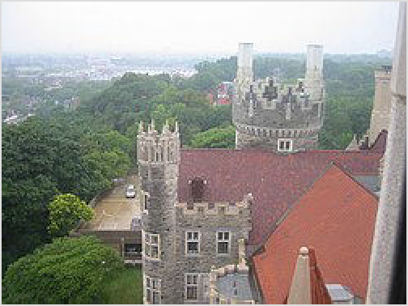Hockey Hall of Fame is both a museum and a hall of fame dedicated to the history of ice hockey.
Casa Loma
Royal Ontario Museum is a museum of art, world culture and natural history. It is one of the largest museums in North America, and the largest in Canada.
Spadina House Museum is in a historic mansion dating from the 1860s. The grounds contain a beautiful garden.
Textile Museum of Canada. Shows drawn from a 13,000-piece collection of textiles from around the world and from other collections.

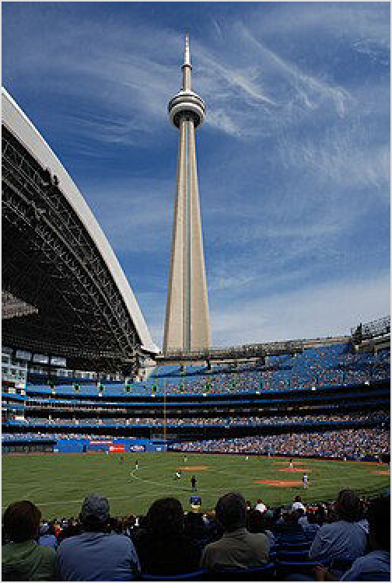Landmarks

CN Tower viewed from Rogers Centre
CN Tower. At 533 metres tall, the CN Tower is the third tallest free-standing structure in the world, and the tallest in North America.
Rogers Centre is a large multi-purpose stadium with a retractable roof. It is home to the Toronto Blue Jays of Major League Baseball.
Toronto City Hall. Two buildings forming a semi- circle overlooking Nathan Phillips Square.
Architecturally stunning, and next door to Old City Hall (now a court house) which has a more classical architecture.

Parks
Toronto Zoo is Canada's premier zoo showcasing over 3,000 animals and over 300 species.

Do

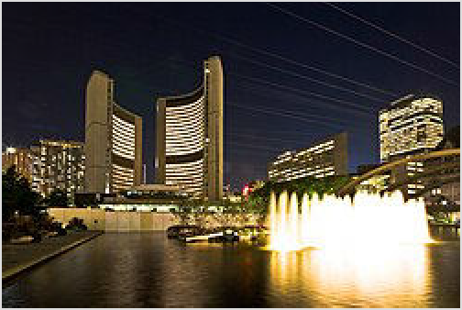Individual listings can be found in Toronto's district articles

Toronto City Hall at night

Outdoors
Toronto is "the city within a park (https://www.toronto. ca/explore-enjoy/parks-gardens-beaches/)", with miles and miles of parkland following the streams and rivers that flow through the city. Edwards Gardens and the Toronto Botanical Gardens in the neighbourhood of North York might just be the place to start exploring this natural environment.
The City of Toronto has designated various Discovery Walks (https://www.toronto.ca/servi ces-payments/streets-parking-transportation/walking-in-toronto/walking-tours/etobico ke-walking-tours/) which highlight the natural and human history of the region. These can be found with brown circular signs along the route and highlight other regions such as the Belt Line, Garrison Creek and the Humber River as well as the downtown core.
Beaches. Toronto has three main sections of beach along Lake Ontario. The most popular of these is in the aptly-named Beaches neighbourhood. A less popular alternative is the beaches in the western end of the city in the Parkdale neighbourhood; this was once Toronto's Coney Island, with an amusement park and numerous beach-style attractions; however in the 1950s the city built the Gardiner Expressway along the lakeshore, effectively separating the beaches from the city and causing the demolition of the amusement park; over the years attempts have been made to re-energize this area, but the Gardiner remains a major barrier, as well as a source of noise and pollution to keep away would-be beach-goers. On the plus side, the beaches are largely empty most of the time, providing solitude for those who seek it. The third major beach area in the city runs along the south shore of the Toronto Islands. This area is pleasantly secluded, with most of the islands covered with parkland and a small amusement park. Hanlan's Point Beach on the western shore of the islands is the City of Toronto's only officially recognized clothing optional beach, and a popular gay hangout. Despite these options, many Torontonians prefer to leave the city for beach trips;

the most popular beaches are those in the Georgian Bay area north of Toronto, Wasaga Beach in particular is very popular during the summer.

Arts & entertainment
Comedy. World-renowned Second City (http://www.secondcity.com/) comedy/improv theatre has a location in Toronto. See great improv and situation comedy performed live with audience participation over dinner and drinks in the heart of the club district of downtown Toronto.
Theatre. Toronto has a great theatre scene for every taste and budget. Check out the big theatres on Yonge Street for the big splashy shows. Small theatres in the Annex and elsewhere offer smaller productions that range from original Canadian works, avant-garde, experimental theatre, small budget musicals to British murder mysteries. A variety of theatre festivals such as the New Ideas, Rhubarb and Fringe festivals are the seed for many commercial success such as The Drowsy Chaperone. Also try to check out the Four Seasons Centre for the Performing Arts (https://www.coc.ca/Venue-Information/fourseasonsc entre), the home of the Canadian Opera Company (https://www.coc.ca/) and the National Ballet of Canada (https://national.ballet.ca/Tickets/Box-Office?). The Toronto Symphony (http s://www.tso.ca/) plays in the acoustically renovated Roy Thomson Hall (https://roythomsonhal l.mhrth.com/).

Annual events
  - Canadian National Exhibition (http://theex.com/) (The Ex, CNE), Exhibition Place. From mid-August to Labour Day. The Ex is an annual fair offering an amusement park (the Midway), a casino, live entertainment, an international market, agricultural exhibits including livestock and a variety of other exhibits. It is Canada's largest fair and the fifth largest in North America, with an average annual attendance of 1.3 million. (updated Jan 2016 | )
Doors Open (https://www.toronto.ca/explore-enjoy/festivals-events/doors-open-toront o/), Various locations. This event, held the last weekend of May, offers residents and visitors an opportunity to take a peek behind the doors of more than 100 architecturally, historically, culturally and socially significant buildings across the city. Many of these buildings are normally not open to the public. A number of the city's museums offer free admission on the Doors Open weekend. Free admission. (updated Mar 2022 | )
  - Fan Expo Canada (https://fanexpohq.com/fanexpocanada/) (Metro Toronto Convention Centre). Canada's answer to the San Diego and New York Comic-Cons, Fan Expo Canada draws over 150,000 attendees each year to celebrate superheroes, science fiction, fantasy, and other popular franchises. It's the largest such event in Canada and one of the biggest in the world, now taking up both the north and south buildings of the Convention Centre. It usually takes place over four days at the end of August. (updated Feb 2022 | )
Pride Toronto (http://www.pridetoronto.com/). Held the last week of June. Pride Toronto is the annual LGBT festival which includes the very popular Pride Parade which draws crowds of straight people to discover how LGBT people have fun. See also LGBT Toronto. (updated Jan 2016 | )
Toronto Black Film Festival (http://torontoblackfilm.com/) (TBFF). Held in February. TBFF showcases the noteworthy black films and provides a forum to debate major cultural, social and socio-economic issues. (updated Jan 2016 | )
Toronto International Film Festival (http://tiff.net/festivals/festival15) (TIFF). Starts the Thursday night after Labour Day. This publicly attended festival of international film takes place in various theatres and draws many celebrities and celebrity spotters. (updated Jan 2016 | )
  - Inside Out LGBT Film & Video Festival (https://insideout.ca/), TIFF Bell Lightbox, 350 King St W. Late May/early June. 180 Canadian ind international films and videos over ten days, produced by and about LGBT people. (updated Jan 2020 | )

  - Toronto International Festival of Authors (https://festivalofauthors.ca/), info@festivalofauthors.ca (mailto:info@festivalofauthors.ca). Late October to early November, with related events throughout the year. One of the largest literary festivals in the world. The annual festival attracts many well-known and up-and-coming authors, with a focus on Canadian and Indigenous authors. Due to COVID-19, the 2020 festival was held online.
Events included author readings and discussions, writing workshops, book club meetings, events for children and families, and audio walking tours of Toronto neighbourhoods that inspired stories about the city. The festival's Instagram page @festofauthors sometimes hosts live online events and announces updates throughout the year. Most events are free. Some events, including the book clubs and the writing workshops, have admission fees: check the festival's website for details. (updated Nov 2020 | )

Exploring neighbourhoods
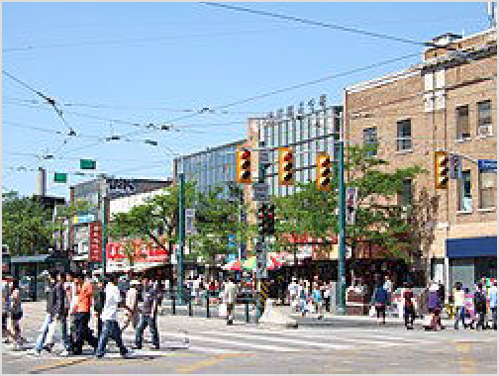Toronto has so many eclectic neighbourhoods that a random walk is fascinating in its own right. You might start in the Downtown area and then try other neighbourhoods around the city. Here are a few suggestions of neighbourhoods to visit. More details and more examples are found in the district articles.

Crowds along Chinatown, on Spadina.

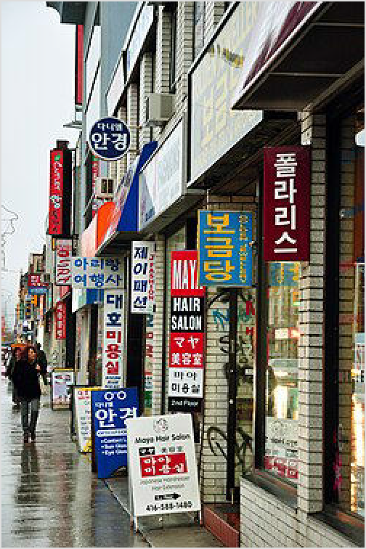Distillery District. The former Gooderham & Worts distillery lands have been rejuvenated into a pedestrian-only village dedicated to the arts and entertainment. It has fantastic restaurants, festivals, and art galleries housed in its 19th-century distillery buildings.

Pedestrian streets in Koreatown.
Harbourfront, Toronto's former industrial port, is today largely parkland with biking and walking trails and excellent views of the harbour. Harbourfront Centre is situated right by the lake, and is home to numerous cultural events of which most are free or relatively inexpensive. Take in some of the worlds most critically acclaimed performing arts productions, or enjoy one of the many world festivals that take place every weekend.
Toronto Islands. A short inexpensive ferry ride from the foot of Bay Street and you leave the bustle of the city behind. Visually, the views of the skyline from the islands are stunning, and for cycling, walking, picnics or just relaxing, the Toronto Islands are hard to beat. There is even a small amusement park for kids, Centreville. On hot summer days, temperatures here will often be about 2-3C lower than the mainland providing relief. By mid-summer the water is warm enough to swim at Hanlan's Point or for the more adventurous, a nude beach is nearby.
Little Italy is the spot to get a sense of the Western Mediterranean. Sit at one of the many coffee shops and watch the world go by on the weekends. A great time to visit is during the men's FIFA World Cup
competition (in football/soccer), regardless of where in the world it is actually being held as local communities face off and rivalries reach a fever pitch. Support can be passionate and

even in adjacent communities and it is not unusual to see them draped in a mind-numbing variety of flags once every four years.
Toronto's Chinatown is a great way to sample a tiny bit of cities like Hong Kong, without spending the airfare. Vast crowds crush the sidewalks as vendors sell authentic Chinese and Vietnamese food, and not-so-authentic knock-offs. It is one of North America's largest Chinatowns, and with many shops aimed at tourists, it is a good place to pick up some unusual and inexpensive souvenirs. The area is also home to a growing number of Korean and Vietnamese shops and restaurants. Toronto's multicultural mosaic never stops evolving. For a complete tour, travel along Spadina (north/south) starting at College Street in the north or Queen Street in the south. However, those looking for good, authentic Chinese food may be disappointed, and most of the restaurants here are tourist traps; these days the best Chinese food can be found in the suburbs of Markham and Richmond Hill.
Kensington Market was once a centre of Jewish life that has morphed into the centre of Toronto's bohemian scene. Visitors will be assaulted by sounds and smells unlike anywhere else in the city, as narrow streets bustle with immigrants, punks, and yuppies alike. Stores include surplus shops, coffee houses, small restaurants (including vegetarian), clothing vendors, and record stores. Fish and fruit markets are also present in great numbers, and the area is experiencing a boom of South American food stalls of late.
Koreatown has many Korean retail businesses and restaurants where Korean is as prominent as English in the signage. (There is also another Koreatown in North York.
Gerrard India Bazaar (Little India) If you want to get a sense of Toronto's vibrant South Asian community, this is where you want to be; not only is Indian culture represented - visible Pakistani and Afghan communities are also alive along the street.
The 501 Queen streetcar has been recognized in National Geographic magazine for being the longest streetcar route in North America (one of the longest in the world). The journey from one end to the other takes a couple of hours and passes through a wide range of ethnic and cultural neighbourhoods.

Sports teams & arenas
Toronto has several major league and minor league sports teams:

Toronto Argonauts (http://argonauts.ca) - Canadian Football League, playing at BMO Field on the Exhibition Place grounds.
Toronto Blue Jays (https://www.mlb.com/bluejays) – Major League Baseball, playing at the Rogers Centre (formerly known as SkyDome, and still generally called such by locals).
Toronto Maple Leafs (http://mapleleafs.nhl.com) – National Hockey League, playing at the Scotiabank Arena (formerly known as Air Canada Centre).
Toronto Raptors (http://www.nba.com/raptors/) – National Basketball Association, playing at the Scotiabank Arena.
Toronto Rock (http://www.torontorock.com) – National Lacrosse League, playing at the Scotiabank Arena.
Toronto Football Club (http://www.torontofc.ca) (also known as Toronto FC or TFC) – Major League Soccer, playing at BMO Field.
Toronto Sceptres (https://toronto.thepwhl.com/en/) – Professional Women's Hockey League, playing at the Coca-Cola Coliseum (formerly the Ricoh Coliseum).
Toronto Marlies (http://marlies.ca/) – American Hockey League (Toronto Maple Leafs farm team), also playing at the Coca-Cola Coliseum.
York United FC (https://yorkunitedfc.canpl.ca/) – Pro soccer team in the Canadian Premier League. They play home games at York Lions Stadium on the campus of York University in North York, but have long-term plans to build their own stadium in the York Region.

Toronto FC II (https://www.torontofc.ca/tfc2/) – MLS Next Pro (Toronto FC reserve team); as of 2024, TFC II shares York Lions Stadium with York United. A couple of home games are played at BMO Field as part of a doubleheader with the parent club.
Toronto Wolfpack (http://www.torontowolfpack.com) – Rugby league team playing in Super League, the top level of England's rugby league pyramid, which also includes 10 teams from England and one from France. The Wolfpack play at Lamport Stadium in the Liberty Village neighbourhood.
In 2026, Coca-Cola Coliseum will also become home to the Toronto Tempo (https://tempo. wnba.com/), a WNBA team.
The Scotiabank Arena (https://www.scotiabankarena.com/), 40 Bay St. It was called the Air Canada Centre (or "the Hangar") until 2018.

The Rogers Centre (https://www.mlb.com/bluejays/ballpark) , 1 Blue Jays Way. Most often referred to by its original "SkyDome" name.

The Maple Leaf Gardens (http://www.mattamyathleticcentre.ca/), 60 Carlton Street. Historic arena in Toronto, on the northwest corner of Carlton Street and Church Street in Toronto's Garden District; now converted into a Loblaws supermarket and an athletic centre for Toronto Metropolitan University (formerly Ryerson University), the Mattamy Athletic Centre at the Gardens.

The Sobey's Stadium (http://www.sobeysstadium.com) (formerly Aviva Centre), 1 Shoreham Drive. A tennis complex that serves mainly as a training facility, but also includes a main stadium court that frequently hosts seasonal concerts. The most notable use of the complex is for the annual Canadian Open (sponsored as the National Bank Open formerly Rogers Cup), a high-profile event on both the men's ATP Tour and women's WTA Tour. The Aviva Centre hosts the ATP event in even-numbered years and the WTA event in odd-numbered years, alternating with Montreal in both cases.

Buy

Toronto has ample opportunities for shopping, and nearly any section of the city has unique places to shop:

Toronto Eaton Centre – At Yonge-Dundas Square. Over 285 shops and services, including most of North America's most popular brands, and two food courts catering for every taste.
The 'PATH' System (http://www.toronto.ca/path/). Linking 1,200 stores and 50 buildings, The PATH is an underground shopping mall has been created for all the commuters to get from Union Station to their offices and back without ever going outside. In a city of Toronto's summer heat and winter cold, this is essential.
Mink Mile. If you head west from the corner of Yonge and Bloor, you are in the most upscale of Toronto's shopping districts, easily accessible from the Bloor-Yonge or Bay subway station. Bloor Street between Yonge and Avenue is regarded as Toronto's version of Fifth Avenue, with upscale names such as Hermes and Louis Vuitton, and the flagship Holt Renfrew department store.
Yorkville. This high-end shopping district just north of Bloor Street and west of Bay Street is home to many designer boutiques. It also has many galleries selling art.
Kensington Market provides a bohemian shopping experience especially along the southern end of Kensington Avenue. The houses lining both sides of the street have been turned into shops with racks of clothes displayed in the front yard.

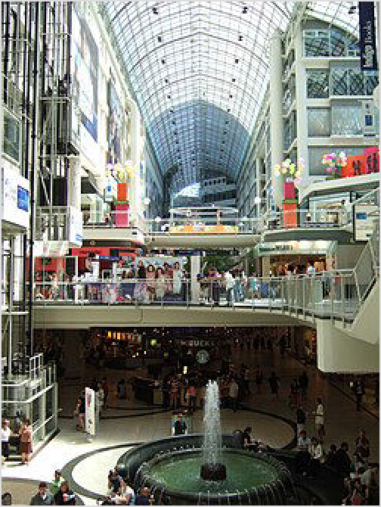There are many local, neighbourhood shopping districts in the inner city. These are mostly along major thoroughfares lined on one or both sides with shops in low-rise buildings. A few examples are Queen Street West (especially east of Spadina Avenue and extending westward into the West End), Uptown Yonge north of Eglinton Avenue on Yonge Street, and Roncesvalles Village. There are many more areas with store-lined streets within the inner city but few in suburban districts such as Etobicoke, North York and Scarborough which tend to prefer malls. Consult the district articles.
Yorkdale Shopping Centre (http://www.yorkdale.c om/). A shopping centre in the north of the city, accessible from Yorkdale subway station. This is a full-service, upscale mall with hundreds of stores, but which is also rife with packs of roving teenagers who use the facilities as a social scene. Make use of the subway if possible on weekends, as locals pack the parking areas to capacity.

Money

Interior view of the Toronto Eaton Centre.

Changing money at a recognized bank or financial institution is best; there are a few specialized bureaux de change in Toronto's financial district and in Mississauga in the airport terminals. Some hotels, souvenir shops and tourist offices exchange money, but their rates won't put a smile on your dial. Many places in Toronto accept US dollars for small transactions – with a rough 1:1 exchange rate – and it is advised to obtain some Canadian dollars if you will use cash. US coins are often mixed in with Canadian coins at stores since they are similar in appearance.

Travelex (www.travelex.com/ca) has branches in the Financial District (+1 416-304-6130; First Canadian Place, Bank of Montréal, 100 King St W; M-F 8AM-5PM) and at the airport in Mississauga.
Calforex Currency Services (290 Queen St West) give good rates for cash, buying and selling GBP, USD, EUR; on substantial sums can be as little as 1% from interbank rates.
American Express branches in Toronto only function as travel agencies and don't handle financial transactions.
Cheque-cashing firms such as Money Mart (+1 416-920-4146, multiple locations) can usually exchange US to CAD, but the rates tend to be worse than at other financial institutions.

Eat

Toronto is generally considered to be one of North America's top food cities. It has the same variety as New York or San Francisco and the compact and safe downtown keeps them closer together. As one of the most (if not the most) multicultural cities in the world, Toronto has authentic ethnic cuisine like no other city in North America. It is easy to eat out in Toronto and have a superb meal for cheap.

A few of these cheap (i.e., can be easily procured for less than $20 or, in many instances, $10), iconic dishes are must-try meals for any visitor to Toronto—and represent the diversity that makes this city so special.

Roti
Roti (never plural, and make the effort to pronounce the "T", like "row-tee") is probably the city's most iconic dish. Originating in Trinidad and Guyana, roti is essentially a curry wrapped in a roti shell, i.e., a thin paratha or dhalpuri flatbread. Typical curries found in roti include goat, chicken, lamb, beef, shrimp and a range of veggie options (channa, spinach, pumpkin, cabbage, potato). Occasionally you can find duck and oxtail options, if you're lucky. While the best roti is found in the outer suburbs of Scarborough and Brampton, a handful of shops persist in the city proper, including:

Pam's (Bloorcourt)
Ali's West Indian Roti Shop (Parkdale) Island Foods (West Queen West) Paul's Roti Shop (Cabbagetown)
Randy's Roti and Doubles (Bloor/Yonge)
A second variety of roti is a true Toronto original, despite the constituent ingredients being from India. Enterprising Indian cooks in the city saw the popularity of the Caribbean/West Indian- style wrap and adapted it to their own curries; the East Indian variety is now much more easily found than the West Indian original, but it must be said the quality ranges from divine to barely tolerable. Classic choices include butter chicken, matar paneer, channa and lamb korma. Your best bets for consistently excellent Indian roti:

Roti Mahal (Queen West) Matha Roti (Harbord Village) Mother India Roti (Parkdale)

Jerk chicken
Toronto's home to one of the largest Jamaican populations outside of Jamaica, and with that comes a dazzling array of incredible jerk chicken options in nearly every corner of the city. This spicy-sweet-savoury chicken is usually served with rice and peas (kidney beans) and coleslaw; ask for extra oxtail gravy for the true taste. Meals can be had for $10–15, often with lunch specials. Little Jamaica, along Eglinton Ave., has about a dozen or so exceptional options; some classics closer to the core of the city include:

The Real Jerk (Gerrard East—they filmed the music video for Rihanna's "Work" ft. Drake here!)
Allwyn's (Queen West)
Fahmee Bakery (Little Portugal)
Chubby's (King West—a more expensive but supremely delicious version) Tasty's (Chinatown)
Jerk King (numerous locations including Chinatown, the Annex and Bloor/Dufferin) Mr. Jerk (Cabbagetown)
Diner's Corner (Yonge/Wellesly) Albert's (St. Clair)

Patties (or "Jamaican patties" or "beef patties")
Patties are a flaky-crust pastry usually filled with seasoned ground beef and can be purchased from Jamaican restaurants, convenience stores, and even a couple subway stations. Vegetable and chicken versions can be found with a little effort as well; for a huge range of fillings (shrimp curry, callaloo, goat, ackee and saltfish), head to Golden Patty in Kensington Market.

Doubles
Doubles are the "little snack that fill you up big"—curried chickpeas in a fried, doughy flatbread, often with some tamarind sauce and hot sauce thrown in for good measure. Originating in Trinidad and Tobago, these can be found pretty much wherever you can find Caribbean roti, and typically will cost you under $5. Randy's and Ali's make particularly great doubles.

Italian veal sandwiches
Bring your appetite for these massive sandwiches. A Toronto Italian classic, veal sandwiches usually feature two or three breaded veal cutlets in tomato sauce with cheese, onions and peppers, all served on an Italian roll. Most veal sandwich shops also offer chicken cutlets and eggplant options as well for those looking for something somewhat lighter. More easily found around the West End than anywhere else in town, put yourself in a food coma at one of these shops:

California Sandwiches (Little Italy) Bitondo's (Little Italy)
San Francesco Foods (Little Italy) Tony and Nick's (Little Portugal) Papamio (Annex/Seaton Village)
Uno Mustachio (St. Lawrence Market)

Portuguese tarts
Toronto has one of the largest Portuguese populations of any city outside of Portugal or Brazil, which means you can find excellent pasteis de nata—flaky custard tarts—at bakeries all over the city. While gentrification of the traditionally Portuguese areas of Toronto's West End has resulted in the closures of many iconic bakeries since the 2010s, options still abound. Many bakeries will put their own spins on the tarts, with chocolate and nutella being popular options. Check out these bakeries for quality pasteis:

Nova Era (multiple locations, including Dundas, St. Clair and Dupont) Golden Wheat (Little Italy)
Caldense (Little Portugal)
Brockton Village Bakery (Little Portugal) Bom Dia (Parkdale)
Progress Bakery (Dovercourt Village)

Street meat
Like any proper North American city, Toronto has a distinct regional spin on the hot dog, albeit one that is much less fussy than you would find in Montreal, Chicago, Tucson or Detroit. "Street meat" carts are found all over downtown, with many options clustered along Front Street near the Rogers Centre as well as near Nathan Phillips Square. Most carts will offer four sausage options: hot dog, Italian sausage, Polish sausage and veggie; hot dogs will run you ~$4, with sausages going for a dollar or so more. You dress the dogs yourself, with common toppings including ketchup, mustard, relish, onions, sauerkraut, pickles, banana peppers and bacon bits. There's no agreed-upon "standard" set of toppings; just do what feels right!

Farmer's markets
Surrounded by the extensive fertile farmlands of Southern Ontario, Toronto has an abundance of farmer's markets - one is happening, in season, almost every day. Several markets are year round, while others are seasonal, generally running from May to October.

St. Lawrence Market: The larger main building has over 50 specialty vendors, with a large seafood section, a dozen butchers, several bakeries, and three very extensive cheese shops. In the basement, there is a specialty area for handcrafters, and an extensive foodcourt. The temporary building is home to a Farmer's Market, open Saturdays year round. It features fresh vegetables in season, preserves, spices and herbs, honey direct from the beekeeper or maple syrup from the people who tapped and boiled it, and quality Ontario wines.
Riverdale Farm in Downtown East is a working farm with an onsite store.
Seasonal farmers' markets are held at City Hall's Nathan Phillips Square, in the Yonge-Dundas area, East York Civic Centre in the East End, Etobicoke Civic Centre in Etobicoke, North York Civic Centre at Mel Lastman Square, Scarborough Civic Centre in Scarborough, Dufferin Grove Park in the West End, and Green Barn Market in the West End

Interesting food districts
Kensington Market is a historic market near Chinatown with food and drink options of all kinds. These days, Latin food (especially Mexican tacos and South American empanadas) is particularly well represented, but Caribbean, Italian, Middle Eastern and Canadian food are all found in abundance, along with coffee shops, bars, food stores and vintage stores.
Cabbagetown is a designated Historic District in the eastern half of the downtown core.
University District: small section of Baldwin Street (east of Spadina, north of Dundas) has many small outdoor cafes ideal for summer lunches.
Chinese food can naturally be found in Chinatown, but these days many ethnic Chinese residents will tell you that the suburbs of Markham and Richmond Hill, not Chinatown, have the best Chinese food in the Toronto area. Other areas with a good selection of Chinese food include the suburbs of Scarborough and North York, as well as the neighbourhood of East Chinatown, about 4 km east of the original Chinatown.
Chinatown also has many Vietnamese and Thai restaurants.
Hakka food is a style of Chinese food that originated in India with the migrant Chinese of Kolkata. Also known as Indian-style Chinese food, outside of India and certain Southeast Asian countries, Toronto is the only city in the world to have such a variety of Hakka restaurants.
Little Jamaica along Eglinton is home to countless jerk chicken restaurants as well as options for beef patties, ital (vegan) food and more.

Little India along Gerrard Street East features a wide range of Indian and Pakistani cuisine with plenty of options for vegetarian diners.
Koreatown along Bloor West between Bathurst and Christie Pits has dozens of Korean restaurants at every price point, as well as Korean karaoke bars and an incredible Korean grocery store, the P.A.T. (don't skip the fish waffles!).
Little Tibet in Parkdale is home to more than 20 Tibetan restaurants, one of the largest such communities outside of Tibet. Wherever you go, try the momos (dumplings with hot sauce)!
Greektown along the Danforth features plenty of places for souvlaki, meze, gyros and glorious dips of all kinds.
Little Portugal along Dundas West has gentrified considerably but there are a few remaining bakeries with pasteis de nata (custard tarts), bifana (pork sandwiches) and the like.
King Street between University Avenue and Spadina Avenue has many restaurants appealing to theatre goers.
Queen Street East between Empire and Leslie has a number of casual, trendy restaurants that match the vibe of Leslieville.
College Street to the west of Bathurst has a cheaper set of eclectic restaurants popular with university students from nearby University of Toronto.
Bayview Avenue south of Eglinton is the location of some of Toronto's best French pastry shops.
Bloor Street to the west of Spadina in the Annex has a similar set of restaurants to College St, with a particularly heavy concentration of budget-friendly Korean and Japanese restaurants. Most restaurants tend to be very laid back.
Yorkville: it's more about being seen than actually eating but there are a few hidden gems, and this area is famous for sightseeing celebrities. Restaurants often charge a premium for otherwise mediocre meals.
The city's largest newspaper, the Toronto Star, once chose the Downsview Park Flea Market food court as the best in the city. Although it is open only on weekends and rather remote, it offers a variety of authentic food from Afghan to Trinidadian and lacks the chain restaurants that dominate the city's food courts. It is north of downtown, but is accessible from the Downsview subway station on the Spadina line and shares space with over 400 independent retailers.

Cafés

Check the district articles for independent coffee shops.

Aroma Espresso Bar (https://www.aromacafe.ca/). This cafe chain has locations throughout the city. Aroma might be the best of the large coffee chains for espresso coffees and rivals the quality at many independent coffee shops. The coffee is served in a cup and saucer with a metal spoon (you might not get the spoon at some other places), and you get a piece of chocolate (a nice touch). (updated Aug 2024 | )
Balzac's (http://www.balzacs.com). Balzac's is a small chain of cafes in interesting neighbourhoods. It serves only organic, Fair Trade coffee, cocoa and sugar, and its milk is locally sourced and organic. (updated Jan 2017 | )

Vegetarian
Some districts with vegetarian restaurants are Kensington-Chinatown, The Annex, and Chinatown East.

Drink

Historically, the majority of nightlife in Toronto has been centred on the appropriately named Clubland and in the Fashion District on Queen Street West. Nearly everywhere is packed to the brim with pubs and bars, but none so much as Adelaide and Queen Street in those districts. Clubs tend to operate on Richmond and Adelaide streets (both run east-west, 1 block apart); names change frequently, but the district keeps on going. John Street between Adelaide and Richmond is always a hub of activity, especially after Blue Jays games, and is a convenient spot for those staying downtown. Two other clubs of note outside this district: the (long-lasting) Phoenix (on Sherbourne) and Rebel (literally operating on part of Toronto's commercial port, but this place has an outstanding view of the city on warm summer nights, and boasts an extensive entertainment complex).

Some of Toronto's newest and hottest nightclubs have opened up in the King Street West/Liberty Village area. This area tends to attract a more mature (25 years and older) crowd; however this comes at a cost as drinks and admission into the venues are typically a bit more expensive here than in Clubland.

Hip art and music oriented crowds tend to gravitate towards Parkdale (Queen West past Bellwoods Park). The hipsters hangout in the wide array of bars, galleries and clubs that dot the area, including the Rhino, Happy Wine Bar, Tammy's, Motel, Pharmacy Bar, Danu, Food & Liquor, the Grand Trunk and the Drake and its poor cousin Gladstone Hotels. The same folks also frequent the Annex, Dundas West and Kensington Market areas of the city at night for club nights, casual drinks and art and music events. One of the main "corsos" of the city is Little Italy: College Street, between Bathurst and Ossington flows over with music, sidewalk cafes and excellent food and a crowd that enjoys the summer heat and the offerings. College Street, east of Bathurst, is home to many student hangouts, including Sneaky Dee's which is famous among locals for its nachos. The legal minimum drinking age is 19.

Dundas West has emerged as the preferred stretch of bars and restaurants catering to the taste- making proclivities of West Enders. From Bathurst until Dundas hits Roncesvalles, you will come across all kinds of bars at all kinds of price points: high-end cocktail bars (the aptly named Cocktail Bar, Rhum Bar, Northern Belle, Bluebird), dive-ish bars (Wasted Youth, Lucky Shrike, Hank's Liquor, Swan Dive), wine bars (Tommy's, Milou, Grapewitches, Midfield), cozy date spots (Communist's Daughter, Bathurst Local, Black Dice, Archive, Loveless), live music venues (the Garrison, Lula Lounge, the Dakota); you name it, you can find it.

Ossington between Dundas and Queen has cemented its status as a nightlife hotspot with more than a dozen bars, packed sidewalks and bustling restaurants. While there are certainly a few trend-chasing spots catering to 905ers and basic Millennials, there are some real gems along this stretch, including Sweaty Betty's, Reposado, Bellwoods Brewery and Painted Lady.

Bloor Street West from Christie Pits Park until Lansdowne is also home to a great stretch of bars, including Civil Liberties, Paradise Grapevine, Hurricane's, Grey Tiger, Burdock Brewing, Three Speed, Bar Neon and many, many more. These cater more to the millennial crowd than some of the younger-oriented bars further south but are where you'll find a more authentic expression of what 2020s Toronto is all about.

Toronto has over a dozen microbreweries. One popular microbrewery is Steam Whistle Brewing (south of the CN Tower in the Entertainment District) which offers tours of its brewery in a former locomotive roundhouse. Unlike Steam Whistle, most microbreweries in Toronto are brewpubs serving in-house brews with pub fare. About half of the brewpubs are in the West End district. Other districts having a brewpub are Harbourfront (Amsterdam BrewHouse), Distillery District (Mill St. Brew Pub), Midtown (Granite Brewery) and East End (Left Field Brewery).

As of 2023, craft breweries have consolidated in two general areas: the East End, mostly along Queen East (Eastbound, Radical Road, Avling, Rorschach, Saulter Street, Black Lab) and Gerrard (Left Field, Godspeed); and the West End, particularly near Bloordale/Junction (Steadfast, Henderson, Halo, Indie Ale House, Junction Craft, Burdock, Bandit, Woodhouse, High Park). A few other neighbourhood breweries worth exploring include Bellwoods Brewery (Ossington, near Trinity-Bellwoods), Blood Brothers (Geary Ave.), Kensington Brewing (Kensington Market) and Mascot (Downtown core). For an exceptional beer bar, visit either Bar Volo (near Bloor/Yonge) or its sister shop, Birreria Volo (College near Bathurst).
Toronto has long been a beer and whiskey town, and while it lacks a drinking identity like that of Philadelphia or Boston, asking a bartender for a blackbird shot (Montenegro and Wild Turkey) will endear to you many. Some bars will offer a shot of Jameson + bottle of beer for $10 or so; Wasted Youth and Lucky Shrike on Dundas being two such examples.

Sleep

Individual listings can be found in Toronto's district articles

Most hotels and hostels are situated directly outside the downtown core. Prices for rooms generally range from $150 for a standard hotel, $60–80 for a motel, and $20–40 for a bed in a hostel.

Hotels
Toronto has a wide variety of hotels that can suit every budget. Many are located in the Entertainment and Financial Districts and Yonge-Dundas areas.

Hostels
Toronto has several youth hostels, including ones in the downtown area, such as HI-Toronto Hostel (http://www.hostellingtoronto.com/) at the foot of Church Street.

Bed & Breakfast
Another popular alternative for over nighters are bed & breakfasts, of which Toronto has hundreds, many of them in the downtown core. Prices range from $60 to several hundred dollars depending on the house and amenities offered.

Learn

International students often prefer to study in Toronto because of its safety, proximity to other tourist destinations, and favourable exchange rates and visa policies. However, despite its status as the largest city in the country and Canada's economic centre, it is surprisingly under-served by universities. This lack of post-secondary education has led to the development of major universities in the mid-sized cities that surround Toronto: the University of Waterloo and Wilfrid Laurier University in Waterloo, the University of Guelph in Guelph, McMaster University in Hamilton, Brock University in St. Catharines and Trent University in Peterborough. The universities in Toronto remain some of the best in the country:

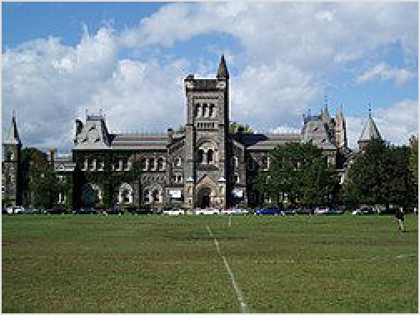University College at the University of Toronto

The University of Toronto (https://www.utoronto.ca/). Canada's largest university, is spread out all over the city (including the main downtown campus, an east-end Scarborough campus, and University of Toronto at Mississauga (UTM) in the neighbouring city of Mississauga). This university is consistently rated among the top three in the country and is part of the "Canadian Ivy League." Due to its size, the University of Toronto's downtown campus, known as the St George campus, after the street that runs through it, has its own "sphere of influence," turning the surrounding neighbourhoods into miniature college towns, with plenty of bars, restaurants, bookshops, grocery stores and cheap take-out joints. Click the link for a guide to the U of T campus.
York University (https://www.yorku.ca/). The third largest university in Canada, York University has two campuses - the Keele Campus near Keele Street and Steeles Avenue West at the northern border of the city, and the original Glendon College at Lawrence Avenue East and Bayview Avenue. York University station on subway Line 1 Yonge–University is within the Keele campus. Buses 124 and 162 connect Lawrence Station (also on Line 1 Yonge–University) to Glendon College.
Toronto Metropolitan University (https://www.torontomu.ca/) (TMU – formerly Ryerson University). In the heart of the downtown core. It was once a polytechnic, but is now Toronto's third university. The university is particularly well known for its school of management, and for its journalism program. Its campus is centred on the Kerr Hall, which forms a square around a central quad, it fills the block bounded by Gould, Gerrard, Victoria and Church streets. TMU also has buildings throughout this section of the city, including the Ted Rogers School of Management, at Bay and Dundas streets.
OCAD University (https://www.ocadu.ca/). The university focuses exclusively on art and design. The campus is on Dundas Street West near Spadina.
Seneca College (https://www.senecapolytechnic.ca/). Canada's largest college is spread out over the city with over 16 campuses of varying sizes.
George Brown College (https://www.georgebrown.ca/). Three campuses: St. James (downtown), Casa Loma (midtown) and Waterfront (Harbourfront).
Humber College (https://www.humber.ca/). Two campuses: Lakeshore and North.
Toronto, like other Canadian cities, also has dozens of English as a Second Language (ESL) schools. The largest association of private English and French language schools is the Canadian Association of Private Language Schools (http://www.capls.com).

Connect

Calling

For life-threatening emergencies or crime in progress, dial 9-1-1 on any landline, mobile or pay phone (toll-free).
Local calls at pay phones cost 50 cents. Toronto's local calling area extends roughly from Oakville to Ajax; Oshawa, Hamilton and their adjacent suburbs are long-distance. Local calls are not metered, so you can talk as long as you want. Due to the popularity of cellphones, there are fewer pay phone booths than in previous years, so they can be difficult to locate. Most large public facilities still have ample pay phones to use. In malls, pay phones are usually between the inner and outer doors at the entrances. Payphones are also routinely provided in TTC subway stations, including on the platforms, as a safety feature. 5G cellular service is available in all subway stations, and coverage is now rolling out in the tunnels with completion expected by late 2026. In other underground areas, such as the lower levels of malls and in the PATH, reception is generally available, if somewhat weaker.

In addition, many public facilities (such as shopping malls) now also have phones which provide free local calls, which are funded by advertisements run on colour LCD screens. Watch for large, wall-mounted ovals in high-traffic areas.

Toronto has four area codes: 416, 647, 437, and 942. These area codes are all associated with the same geographic area. The suburban areas outside of the city have three overlapping area codes: 905, 289, and 365. As a result, Toronto has 10-digit local dialling. You must always dial the area code as part of the number you are trying to reach.

International calling cards are widely available to many countries for reasonable rates. As coin- paid long distance calls are overpriced (Bell payphones charge nearly $5 in the first minute and a lower rate thereafter, competitors are $1 for three minutes), if you must place toll calls from telephone booths, it's best to buy prepaid cards.

Internet
Most coffee shops, chain restaurants, shopping centres and public buildings provide free Wi-Fi. Major attractions such as the Art Gallery of Ontario, Royal Ontario Museum, the Scotiabank Arena and Rogers Centre provide free Wi-Fi to guests.

Wi-Fi and free internet access is available on computers at Toronto Public Library (https:// www.torontopubliclibrary.ca/) branches. Computer access requires a library card, but the library offers a card for in-library services for non-residents without an annual fee.

All TTC subway stations have 5G mobile phone coverage, but free Wi-Fi is no longer offered since the TCONNECT network was shut down in December 2024.

Mail
Generally stamps are purchased and parcels are weighed and shipped at a postal outlet in a retail store such as a variety store or a drug store such as Shoppers Drug Mart. Postal outlets may sell philatelic items (recent issues only).

Newspapers
The Toronto Star (https://www.thestar.com/), a broadsheet daily newspaper, politically left of centre, covering local, national, and world news. Superman co-creator Joe Shuster, who once delivered this paper, used the Old Toronto Star Building (no longer extant) as inspiration for "The Daily Planet" newspaper.
The Toronto Sun (https://torontosun.com/), a tabloid daily newspaper, politically conservative, covering local, national, and world news.
The Globe and Mail (https://www.theglobeandmail.com/), a broadsheet national daily with local edition, published in Toronto. Extensive business and stock market coverage, politically centrist.
The National Post (https://nationalpost.com/), a broadsheet national daily, moderately conservative.
Depending on where you go in Toronto, you will be able to find locally printed newspapers in a variety of languages. For example, in Chinatown, you will find Chinese newspapers. In "Little Italy", you'll find Italian newspapers. You'll also find newspapers in French, Spanish, Portuguese, Persian, Arabic, Tagalog, Greek, Urdu and more.

Stay safe

Crime
The overall violent crime rate in Canada, and particularly in Toronto, is lower than that found in major cities in the United States. Petty crime is generally not a serious problem in Toronto, but be vigilant with your possessions. Car and bike theft are comparable to other large North American cities.

There are neighbourhoods which are known in the media and on the street as being more dangerous, though police statistics are not commonly used to justify these beliefs. Nevertheless, while assaults and other crimes can happen anywhere, especially late at night when few people are around, it is reasonable to avoid certain areas (again, generally late at night). These areas include in the old city and inner bouroughs: Crescent Town, Regent Park, parts of Parkdale, parts of St. Jamestown, Moss Park, Alexandra Park, Flemingdon Park/Victoria Village and Weston-Mount Dennis. Outer areas: Jane and Finch ("Jane Corridor"), Lawrence Heights, the Peanut (i.e., Don Mills and Sheppard), Rexdale/Jamestown Crescent, Malvern, Kingston and Galloway, Steeles-The Amoureaux, Dorset Park, Westminster-Branson and Eglinton East- Kennedy Park. Stay away from dodgy looking areas, where drugs, prostitution and violent crime such as armed robberies can occur. These neighbourhoods become noticeably worse from a visual standpoint, giving ample warning to turn around.

Homeless
Toronto has a visible homeless population, many of whom will ask you for money. Beggars in Toronto have been known to ask for handouts on the pretext that they need TTC (Toronto Transit Commission) fare. Homeless people can also be seen in many subway stations and sleeping across multiple seats in subway cars. Cases of open drug use in the subway are also not uncommon.

There have also been instances in the past with "squeegee kids" who would jump into intersections when traffic is stopped at lights and solicit money for cleaning windshields. This is becoming less common as this form of interference with vehicle traffic is expressly illegal under Ontario's Highway Traffic Act and may be reported to police.

Pedestrians
Be careful when getting off the streetcars and always look to your right before leaving the car. Although vehicles are supposed to stop when the streetcar doors open, some motorists and cyclists will ignore this and keep going.

The proliferation of mobile phones has led to "multitasking" in a large percentage of the pedestrian population of this city. If driving, cycling, or even walking, in Toronto do not forget to keep an eye open for a pedestrian who may be more focused on his or her device.

Weather
Avoid river/creek banks or bridge underpasses during periods of excessive rain, during/after heavy thundershowers or melting snow. Flooding can soften soil and cause it to suddenly collapse into the water under any weight.

Occasionally, Toronto will be hit with a severe winter storm accompanied by significant snowfall (quite often mixed with freezing rain/ice/sleet). Avoid driving during and immediately after the storms if at all possible. This is especially true for those unfamiliar with winter driving and controlling a car in a skid. Take public transit, walk, or stay inside.

Cope

The Office of International Relations and Protocol manages the Government of Ontario’s interaction with the largest consular corps in Canada (and one of the largest in the world). Approximately 100 countries (https://www.ontario.ca/page/consular-offices) are represented in Toronto.

Consulates
list[Expand]
Diplomatic missions

Go next

Toronto is a great starting point for exploring southern Ontario. There are many golden sand beaches along the clean fresh waters of the Great Lakes that are ideal for hot summer days. Popular beach destinations within 1½-2½ hours of Toronto include Wasaga, Sauble Beach, Sandbanks, Grand Bend, Long Point, and Turkey Point.

Golden Horseshoe
Niagara Region — A lush region known primarily for its orchards and vineyards as well as the thundering waterfalls at Niagara Falls and the beautiful town of Niagara-on-the-Lake. On the American side of the Falls are several outlet malls. 1-1½ hours south along the QEW; a few tour buses make the same-day return trip. It is one of the principal Wine Regions of Ontario, and several companies do wine-tasting tours by bus from Toronto, starting at $125 (tax included), such as Niagara Airbus (https://www.niagaraairbus.com/Niagara-Winery-Tour s/).
Main Street Unionville, in the suburban city of Markham north of Toronto, is a historic village developed in the 1840s. As typical of a small village, it has many quaint period buildings in an idyllic surrounding.
Waterloo Region — This area 1-1½ hours west of Toronto has large university campuses, rolling farm hills and Mennonite culture.
The Niagara Escarpment — A world biosphere, protected by UN mandate running from the Niagara Falls west to Hamilton then northward to Georgian Bay. It is covered by forest with high cliff views along the Bruce Trail bordering the western edge of the Greater Toronto Area, at its closest point it is about a ½-hour drive from the western end of Toronto.
Newmarket has its attractive Main Street Heritage Conservation District and many heritage buildings within a walkable area.
Canada's Wonderland is a popular, seasonal theme park operated by Cedar Fair in Vaughan. It is a 20-minute drive away without traffic, and there are buses from downtown in the summer.

Ontario
Muskoka, Georgian Triangle and The Kawarthas — All 1½–2 hours north are cottage country areas with more rocky and hilly terrain speckled with hundreds of lakes and waterways. Muskoka and the Kawarthas are known for their country inns, cottages, spas/resorts, provincial parks, and a wealth of outdoor activities including camping, fishing/hunting, snowmobiling, nature viewing, and hiking set among natural beauty. The Georgian Bay area is where the hilly terrain and cliffs of the Niagara Escarpment meet its shores, the area has renowned ski facilities frequently blasted with high snowfall amounts but beaches Wasaga Beach, wineries and golfing are the choices in summer.
Stratford — This cute town 2 hours west of Toronto is host to the world-renowned Stratford Shakespeare Festival (April–November).
Thousand Islands and Kingston — This scenic area and its nearby historic city are 3 hours east, on the way to Ottawa
Ottawa — The Canadian capital is about a 4½-hour drive from Toronto.
Windsor, London, and Sarnia are at the southwestern corner of Ontario, and the southernmost point of Canada. It is a 3-hour drive.

United States
Buffalo — Gorgeous early 20th-century architecture including some Frank Lloyd Wright work and excellent museums are a 1½-hour drive from Toronto.
Across the Detroit River from Windsor is Detroit, offering Motown music, automobile museums, historic buildings, museums, and theatres. It is 4 hours away.
The city that never sleeps, New York City, is only 8-10 hours away without traffic, via I-90 and I-87. You can also take Amtrak or a 2-hour flight there.
Also an 8- to 9-hour drive away, Chicago is home to blues music, Millennium Park, windy weather, and deep-dish pizza.
If you are into history and want to see the capital of the United States, Washington, D.C., you have to drive 8-10 hours.

Elsewhere in Canada
Montreal is a 6- to 7-hour drive to the east, or a 4½-hour train ride. Bilingual Montreal is home to French-Canadian culture, nice architecture, and the Laurentians are not far away.
You can hop onto a VIA rail train to many parts of Canada, including Winnipeg, Edmonton, and Vancouver.




Routes through Toronto
Winnipeg ← Washago ←  Kitchener ← Mississauga ←  END ←  London ← Oakville ←  END ← | W W  W  W W |  | E E  E E | E | → END  → END  → Oshawa → Montreal / Ottawa  → END  → Oakville → Niagara Falls
Barrie ← Vaughan ← | N | S |  |  | → Ends at 
London ← Mississauga ← | W | E |  |  | → Pickering → Kingston
Newmarket ← Markham ← | N | S |  |  | → Ends at 
Vaughan ← Mississauga ← | N | S |  |  | → Ends at 
Hamilton ← Mississauga ← | W | E |  |  | → Ends at 

Retrieved from "https://en.wikivoyage.org/w/index.php?title=Toronto&oldid=5285341"

